Vocab Chapter 4 Etruria & Rome

1. Abolla- Jessica Fraser 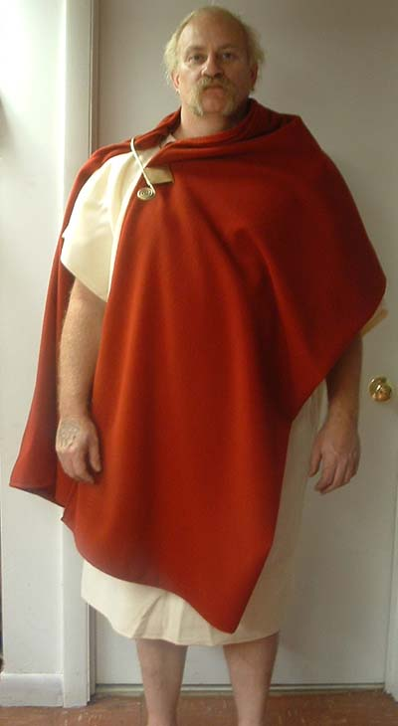

Soldiers and officers would wear this single layer of clothing over their shoulder. It was used for war as well. Although it was worn during the war, it was also worn instead of a toga around the city. It was worn by both the Greeks and the Romans.

I thought it was interesting that half the people would die before becoming an adult. It really makes you think about the war tools we have and the medicine we have now.

Sources:

[https://penelope.uchicago.edu/Thayer/e/roman/texts/secondary/smigra*/abolla.html](https://penelope.uchicago.edu/Thayer/e/roman/texts/secondary/smigra*/abolla.html)

[(Links to an external site.)](https://penelope.uchicago.edu/Thayer/e/roman/texts/secondary/smigra*/abolla.html)

The Book Survey of Historic Costume

<https://en.wikipedia.org/wiki/Abolla>

[(Links to an external site.)](https://en.wikipedia.org/wiki/Abolla)

1. Birrus, Burrus
2. Bulla - Alex Clark

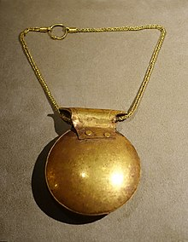A bulla was a type of amulet that was given to the sons of families nine days after they were born. It was typically made up of gold, silver, bronze, or leather and usually contained charms and gems in order to protect against the evil spirits. One talisman that was thought to be potent for warding off evil spirits was the gorgoneion because of the gorgons terrifying appearance and their gaze. The bulla was worn around the neck of the infant, and they would continue to wear it throughout their childhood until they reached adulthood.

Sources:

<https://en.wikipedia.org/wiki/Bulla_(amulet)>

<https://archaeologicalmuseum.jhu.edu/class-projects/archaeology-of-daily-life/jewelry/gold-bulla/>

Survey of Historic Costume, Page 92

1. Clavus, Clavi: Lexie Pincock

Broad purple bands which extended vertically from hem to hem on the shoulder of the tunics. The designs were tapestry woven and placed on the garment. It didn’t have to be a certain color, but red was very common. 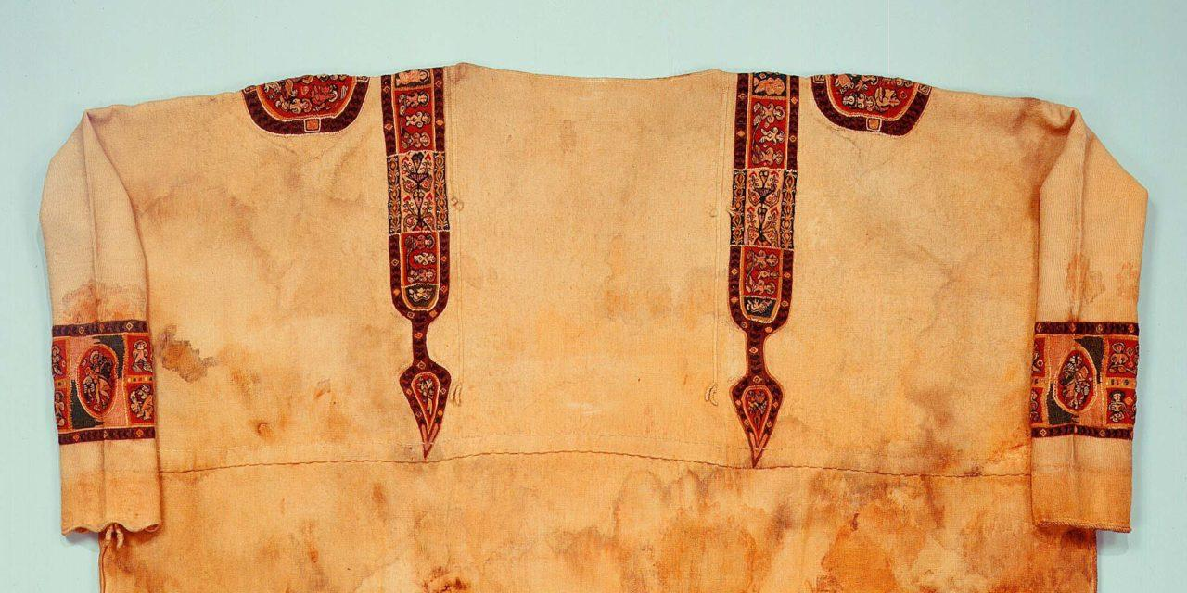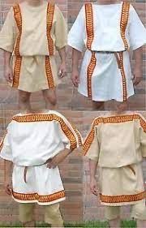

Sources:

<https://fashionhistory.fitnyc.edu/clavus-clavi/>

Pg. 81

1. Dalmatic-Ida Johnson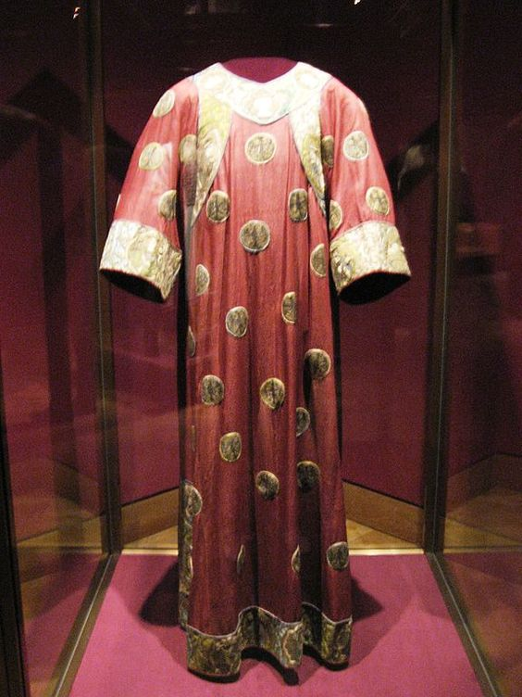

In the Roman Empire, the dalmatic was an amply sleeved tunic (from Dalmatia) with wide stripes (clavi) that were sometimes worked with elaborate designs. Today they are often worn by the Pope or Deacons of various religions. <https://fashionhistory.fitnyc.edu/dalmatic-tunic/> <https://www.patheos.com/blogs/kathyschiffer/2014/09/the-dalmatic-is-dramatic-but-where-did-it-come-from/>

1. Lacerna - Debbi Wright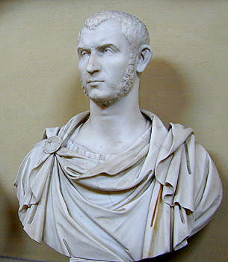

According to our textbook, lacerna is defined as “a rectangular, with rounded corners and a hood”. The lacerna is understood to be a cloak that was fastened on the right shoulder with a buckle or fibula. Apparently the Romans borrowed the lacerna from other peoples and used it in war as a protection from the elements. After some time it became a common article of clothing. Because of this it was outlawed and only certain persons were allowed to wear the lacerna after that.

Toratora, Phyllis G, and Keith Eubank. *Survey of Historic Costume, 5th Edition*. Berg, 2009.

<https://www.google.com/search?q=lacerna&sxsrf=AOaemvL5T9DqyI18D7BwhfeG7x7ERwa2vg:1643046875120&source=lnms&tbm=isch&sa=X&ved=2ahUKEwjontzK-sr1AhXoIDQIHQa3CAIQ_AUoAXoECAIQAw&biw=1366&bih=625&dpr=1#imgrc=7SZZfCs_OXOnFM>

[https://penelope.uchicago.edu/Thayer/E/Roman/Texts/secondary/SMIGRA*/Lacerna.html](https://penelope.uchicago.edu/Thayer/E/Roman/Texts/secondary/SMIGRA*/Lacerna.html)

<http://vroma.org/vromans/araia/lacerna.html>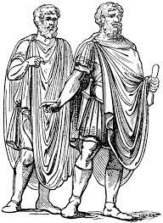

1. Laena -Aubrey Reidhead

The Laena was a garment that was cut as a circle, and folded in half to be draped over the shoulder and pinned in the front. (Pg. 90) This cloak was thick, and would sometimes have a fringe edge. It would be worn over a toga of a priest. It could also have a clasp at the throat to keep it up. (Tribunes and Triumphs) This garment was supposed to be the most ancient garment for Roman men. It was commonly short. (Penn Museum)

I don’t think the image is exactly what I was going for, but this was the closest I could find

<http://www.tribunesandtriumphs.org/roman-clothing/roman-cloaks.htm>

<https://www.penn.museum/sites/expedition/the-imperial-wardrobe-of-ancient-rome/>

1. Mappa - Claire Moore

A mappa is a table napkin. People brought their own napkins to others houses when they were invited as guest. They were also used as to-go sacks so they would carry some of their food/ treats home. Most of the time the mappa was carried by more of the upper class.

Other research found that they would also use a mappa to signal the start of some kind of race. 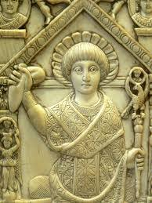

In this picture he is holding a mappa.

Sources

https://sp88k.home.xs4all.nl/Coin/Traveler/Objects/Mappa.htm

<https://en.m.wikipedia.org/wiki/Mappa_(Roman)> Page 90

1. Orarium- **Ryann Becker**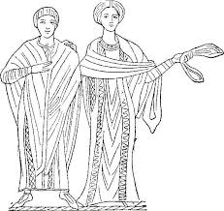

Orarium is a piece of clothing that is draped around the shoulders. Originally from the Romans. Though in more modern times, it is worn by a deacon in the Eastern Orthodox Church. It sets them apart from the others in the church. Etruria had very similar mantle styles. They were all draped around the shoulders. (textbook page 79)

<https://www.collinsdictionary.com/us/dictionary/english/orarium>

<https://www.yourdictionary.com/stole>

1. Paenula- Jensen Stenquist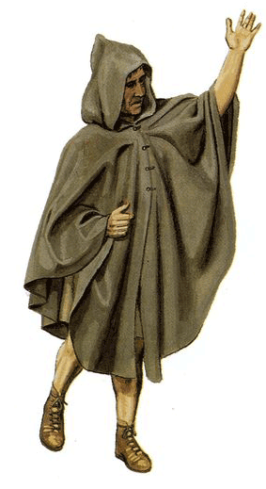

A paenula was a thick cloak. The Romans used the cloak to travel because it would protect them from the cold and the rain. The paenula does not have any sleeves and the only opening is the head hole. It would be sewn in the front about half way down and was divided into two parts. It was usually made of wool, but sometimes it was also made of leather. They were fastened with a cloak pin. The cloak was a semicircle shape with a hood.

[https://penelope.uchicago.edu/Thayer/E/Roman/Texts/secondary/SMIGRA*/Paenula.html#:~:text=PAENULA%20was%20a%20thick%20cloak,20%3B%20Quintil](https://penelope.uchicago.edu/Thayer/E/Roman/Texts/secondary/SMIGRA*/Paenula.html#:~:text=PAENULA%20was%20a%20thick%20cloak,20%3B%20Quintil).

<https://www.romanobritain.org/8-military/mil_soldiers_cloak_.php>

The book

1. Palla- Irelynd Preece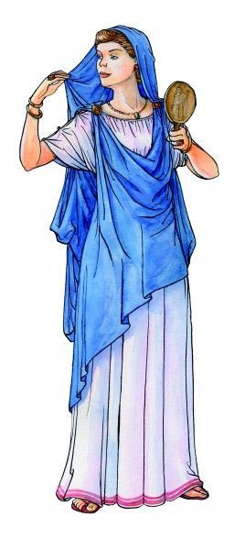

Palla was the most common piece of clothing worn by women in ancient Rome. It was a draped shawl placed over the outer tunic, pulled across the shoulder like a toga or over the head like a veil. Pallas were made of wool, linen, cotton, and silk. However, the silk palla's were worn by the more wealthy women because the silk was imported from the Far East. Palla's were similar to the pallium that men would wear.

Sources:

book

<https://en.wikipedia.org/wiki/Palla_(garment)>

<http://www.fashionencyclopedia.com/fashion_costume_culture/The-Ancient-World-Rome/Palla.html>

1. Paludamentum - Jamie Rakes

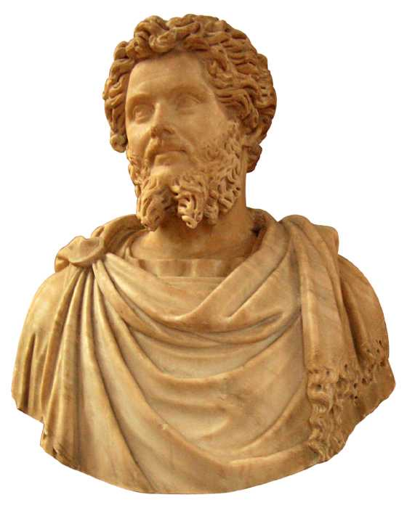

The paludametum was a cape like garment that was fastened on one shoulder. It was worn by military commanders and not so much just regular soldiers. It was also often times worn by a Roman magistrate as well after he received the imperium from the comitia curiata and then offered up his vows to the capital. We still see things like this today with royalty during a coronation or a wedding. The paludametum was normally white or purple. There was no right or wrong shoulder for the clasp to be on and was normally used for practicality

[https://penelope.uchicago.edu/Thayer/E/Roman/Texts/secondary/SMIGRA*/Paludamentum.html](https://penelope.uchicago.edu/Thayer/E/Roman/Texts/secondary/SMIGRA*/Paludamentum.html)

<https://artsandculture.google.com/entity/paludamentum/m02w_hd3?hl=en>

Textbook page 92

1. Rincinum - Jalissa Cloward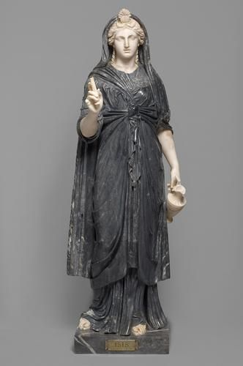

A Rincinum was worn by newly widowed women. It replaced the palla and was most likely dark in color. The widow would wear the rincinum for a year for the time of mourning.

*Survey of Historic Costume* pg. 90

<https://historictrends.weebly.com/costume-blog/the-romans>

<https://greeceandrome.wordpress.com/2014/02/13/standard-clothing-for-the-roman-woman/>

1. Sagum- Brittany Pocock

A Sagum was a thick layer of wool usually red and worn by soldiers in times of war Roman citizens would wear it too. To “put on the Sagum” was an expression for “to go to war.” It was a symbol of war opposed to how the Toga was a symbol of peace. They used wool because of its insulation and water repelation. It was necessary for it to be long since they slept out in the open but also important that they carried it with them all day. 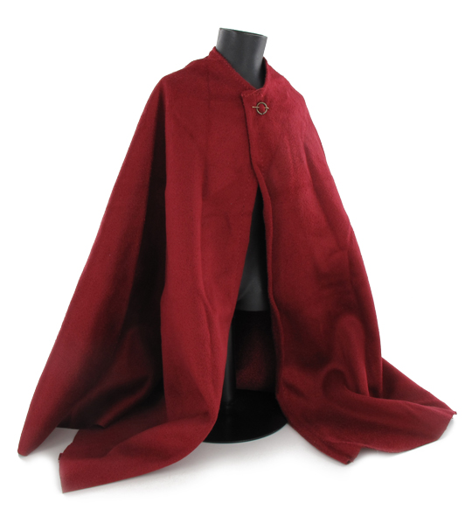

[Sagum | Military Wiki | Fandom](https://military-history.fandom.com/wiki/Sagum)

[Romans in Britain - The Roman Soldier's cloak (romanobritain.org)](https://www.romanobritain.org/8-military/mil_soldiers_cloak_.php)

Page 95

1. Sandalis- Savannah Tanner

“Men and women wore sandals (*in Latin, solae or sandalis*)” Sandalis (or sandals as we refer to them modernly.) were commonly flat footwear with leather straps imported from italy. There were many different variations of sandalis, and they denoted a wearer’s class. The wealthy would commonly accessorize their Sandalis with gold, embroidery or metal.

Pg. 90

<https://www.thoughtco.com/ancient-roman-sandals-and-other-footwear-117819>

<https://www.encyclopedia.com/fashion/encyclopedias-almanacs-transcripts-and-maps/roman-footwear>

1. Solae - Kya Boyd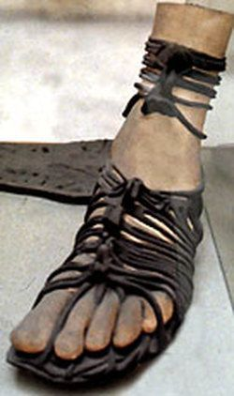

The first sandal found is 5,500 years old and found in a cave with toes fully covered to keep warm. The temperature is warmer in the room, so the shoe was altered into a sandal. Solae is the Latin word for sandals or boots; a slipper-like shoe reaching to the ankle for both men and women to wear. The sandals are leather to protect their feet and the style of the shoe depends on the person's placement in society. If you are a christian or roman civilian you would wear a more simple sandal. Soldiers wore sandals that go up to their ankles with more straps for extra support. Then you have the Gods and Goddesses sculpted wearing more fancy sandals.

Source: <https://earlychurchhistory.org/fashion/shoes-in-the-ancient-world>/

Survey History of Costume Design

1. Stola - Savannah Jeppson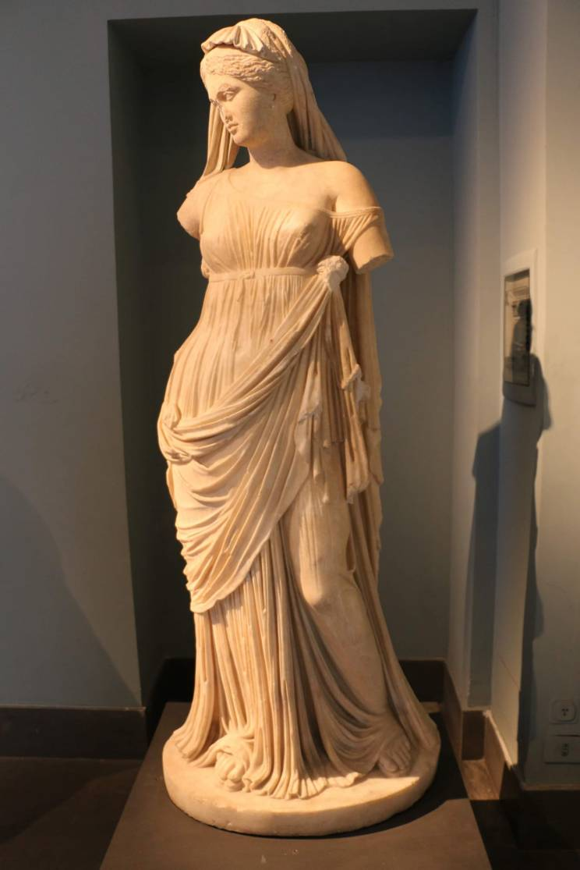

A Stola is a garment reserved for free, married women, and it denoted status. Many scholars have disagreed as to the construction of the garment, but some assume it to be a ruffle at the bottom of the stola that covered the feet, or a modern, pleated slip. Sources:Book, page 89

<https://romanasum.com/2018/05/20/pleated-stola/>

<https://en.wikipedia.org/wiki/Stola>

1. Subligar- Samantha Hooper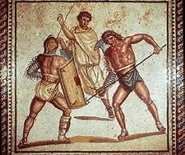

The subligar was the underwear of Ancient Rome. It was essentially a loincloth, but could also be wrapped to be shorts. The female version of the subligar is the subligaria. They were undergarments for the middle and upper class but used as a working garment for slaves. They were also worn during athletic events.

Sources:

Book

<https://en.wikipedia.org/wiki/Subligaculum>

<https://imperiumromanum.pl/en/roman-society/clothing-in-ancient-rome/>

1. Strophium- Abigail Storrer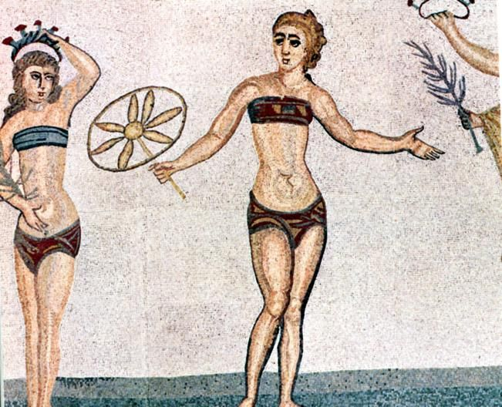

The strophium was a piece of undergarment worn by women in Rome for breast support. It was also a form of breast binding because in Rome it was more attractive to have small breasts. So girls would wear them in hopes it would stop their breasts from getting too big. It was also a Roman version of a sports bra because it was more comfortable to wear when doing physical activities.

Sources:

Tortora, P. G., & Eubank, K. (2010). *Survey of historic costume: A history of western dress*. Fairchild.

<https://jasnime.wordpress.com/2016/05/02/strophium/>

<https://www.phoenixtheatreensemble.org/women-clothing-in-ancient-greece-rome>

1. Sudarium- Hailey Child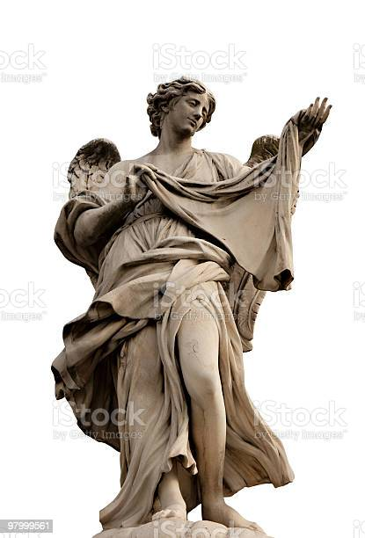

A sudarium is a cloth used to wipe sweat and perspiration from off the face. Usually made of a linen fabric, and used mainly by those in the upper classes. This handkerchief was used on the face and neck and translates from Latin to “sweat cloth”. Used by Roman men in 10 AD, it was a precursor to silk scarves being used to show class and rank in the 17th century.

<https://www.crfashionbook.com/fashion/a22609895/history-of-silk-scarf-fashion/>

Survey of Historic Costume

<https://www.reviewofreligions.org/11770/the-sudarium-of-oviedo-and-the-shroud-of-turin/>

1. Tebenna **Abbie Burns**

A tebenna was a round mantle that was worn by men and women. It had curved edges and some symmetrical form. This garment is what began the toga style for the Romans where the circular draping is what represented romans. The draping of the cloak began by being draped over the shoulder and loosely wrapped around the torso under the right arm. 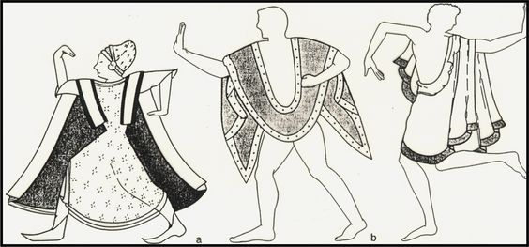

<https://www.pinterest.com/pin/439030663658429359/>

Book pg:78

<http://www.fashionencyclopedia.com/fashion_costume_culture/The-Ancient-World-Rome/Etruscan-Dress.html#:~:text=Similar%20to%20the%20Greek%20chlamys,status%20or%20rank%20in%20society>.

1. Toga-Marisol Dejesus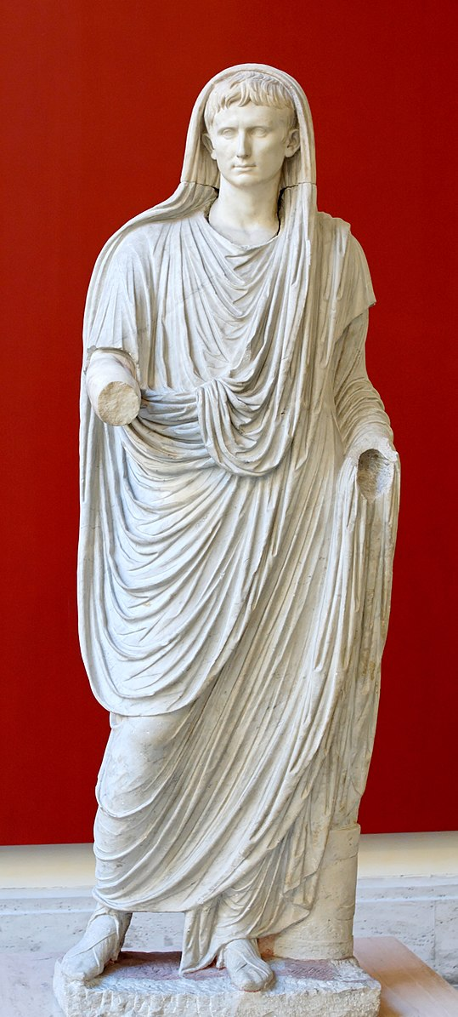

Toga is a draped outer garment that is wrapped around the body and is a length of woolen cloth with round edges. Over time the toga became really symbolic and became restricted, but was worn by both women and men. Then the women abandoned the toga. Later became a garment worn over a tunic by adult men. Finally, it became restricted to male Roman citizens.

Sources:

Book pg.83

<https://www.britannica.com/topic/toga>

<https://www.worldhistory.org/article/48/the-roman-toga/>

1. Toga Candida- Lauren Shumway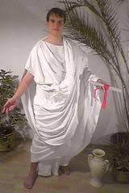

The toga candida was worn by candidates for public office and Senators . It was made of wool and was lighter than the normal togas by rubbing chalk into the fabric. The word candida is where we get the word for candidates.

the book

<https://www.britannica.com/topic/toga-candida> <https://www.thoughtco.com/six-types-of-toga-in-ancient-rome-117805>

1. Toga Picta- Anna Ament The Toga Picta was a purple and gold toga made of wool. Similar to other symbolic traditions among cultures, the color purple represents royalty, the military, and other honorable individuals. The tradition began with the Etruscans and continued even after other styles of Togas went out of style. Eventually, they were common among the Roman empire. This garment was often symbolic of victory among impressionable military events. 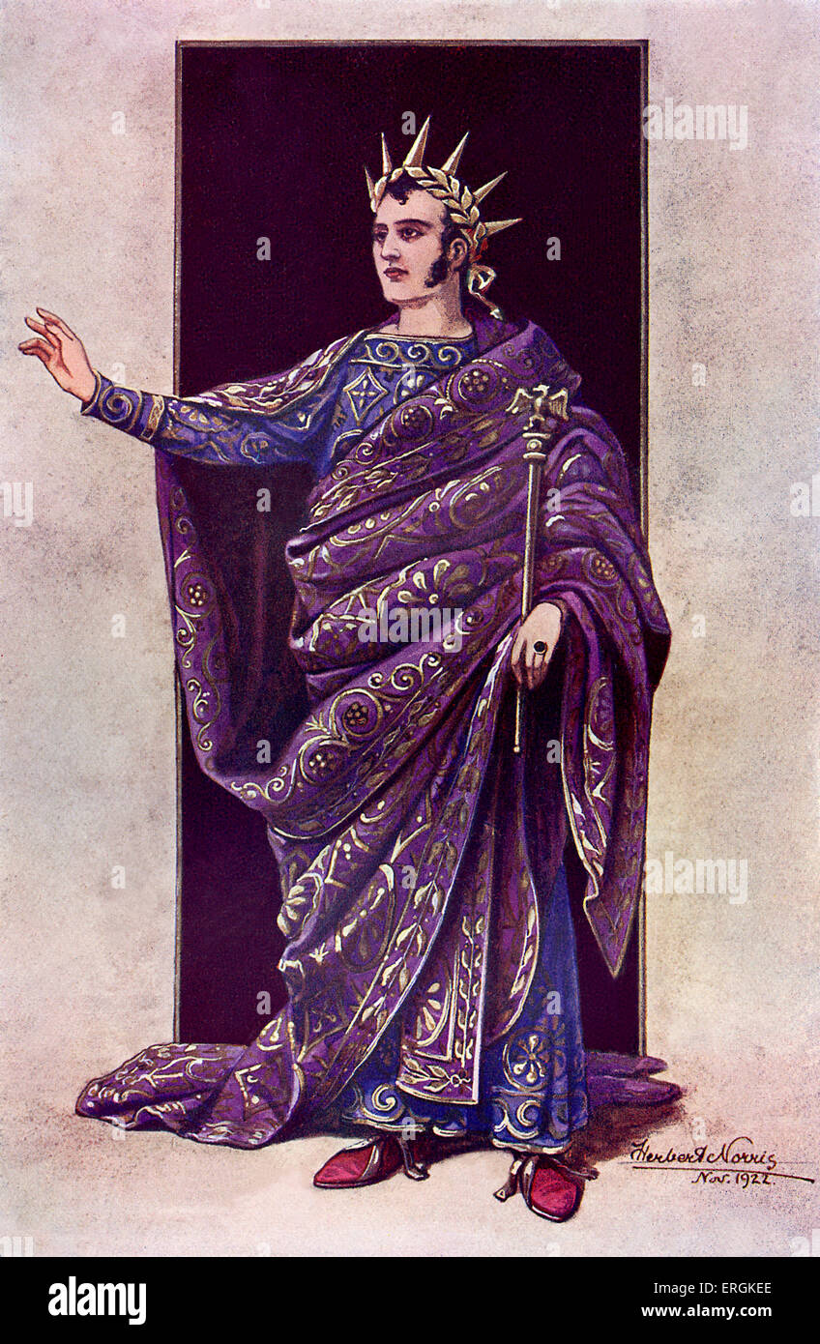

Sources:

<https://fashionhistory.fitnyc.edu/toga-picta/>

<https://www.thoughtco.com/six-types-of-toga-in-ancient-rome-117805>

1. Toga Praetexta - Jocelyn Munoz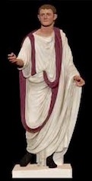

The toga Praetexta was worn by children of nobles or “free-born” adolescents, this garments was usually worn by boys until somewhere between 12-16 and girls usually stopped wearing it after puberty. it’s theorized that boys started wearing the toga pura and girls may have worn a supparum.

Tortora, P. G., & Marcketti, S. B. (2021). two. In Survey of historic costume (pp. 62, 71). essay, Fairchild Books.

<https://earlychurchhistory.org/fashion/childrens-clothing-in-ancient-rome/toga-praetexta/>

<https://www.britannica.com/topic/toga#ref60152>

1. Toga Pulla - Kimberly Tesam Moita

A type of toga that is typically worn during mourning. It was a typical toga but dyed dark. It was worn for the funeral, but not the feasts that accompanied the funerals afterwards, the Romans wore typical garb for the feasts instead of keeping their toga pulla. 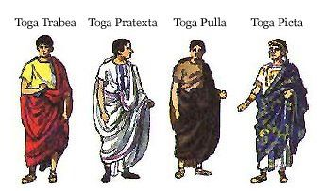

<https://www.britannica.com/topic/toga-pulla>

<https://pressbooks.bccampus.ca/unromantest/chapter/the-roman-man-and-the-toga/>

<https://www.thoughtco.com/six-types-of-toga-in-ancient-rome-117805>

1. Toga Pura: Elizabeth Nathan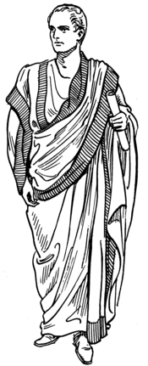

“Toga of Manhood” A plain white toga, worn on formal occasions by adult male commoners, and by senators not having a curule magistracy. It represented adult male citizenship and its attendant rights, freedoms and responsibilities. The toga was a highly symbolic garment for the Romans. It had numerous forms, but the toga pura was the most significant. In its earliest form the toga pura was a

semicircle of white wool.

<https://fashion-history.lovetoknow.com/clothing-types-styles/toga>

<https://en.wikipedia.org/wiki/Toga>

1. Toga Trabea - Claire Lynes 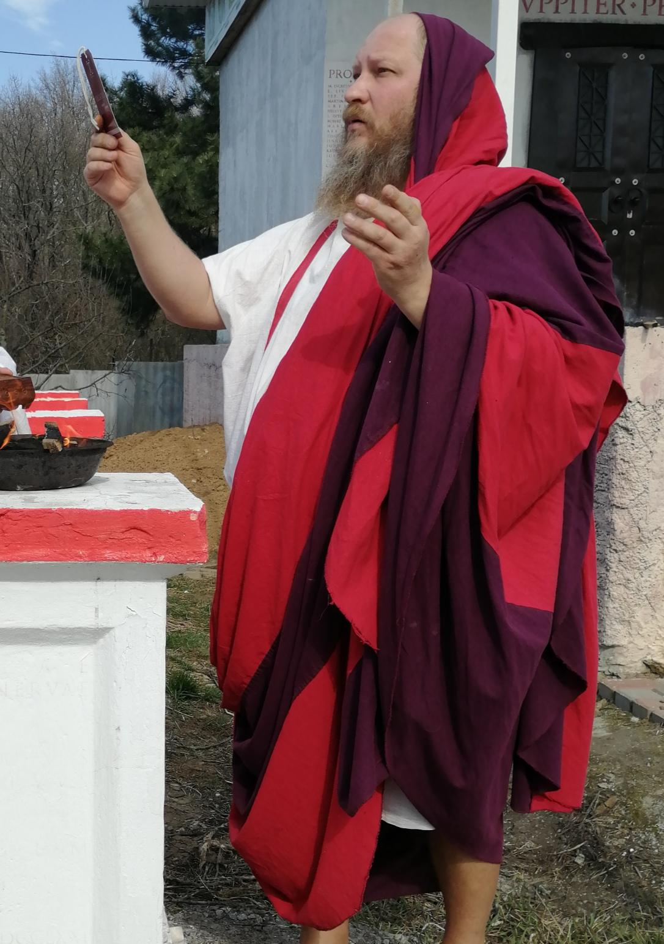

The Toga Trabea was a toga that had a purple border (Ancient Origins). This toga was worn by elites. It was also worn by religious officials (Survey of Historic Costume). Sometimes the Toga Trabea would have stripes of saffron instead or along with the purple (Thought Co).

Sources

<https://www.ancient-origins.net/history-ancient-traditions/togas-and-stolas-0011359>

<https://www.thoughtco.com/six-types-of-toga-in-ancient-rome-117805#:~:text=Toga%20Trabea%3A%20There%20was%20also,saffron%2C%20called%20a%20toga%20trabea.&text=The%20toga%20picta%20was%20worn,truly%20a%20%22royal%20purple.%22>

Survey of Historic Costume, page 83

1. Toga Virilis - Amanda Hair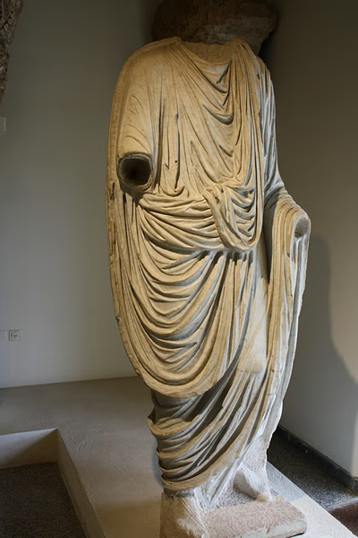

Togas were very significant for the citizens of rome. It was made of a single length of wool cut in a semicircle. This would then be wrapped around the body without any fastenings. It was a status symbol. The Toga Virilis is what boys would begin wearing at the age of about 15. This was to symbolize the beginning of manhood (and end of puberty). World History.org explained that, “While most togas were white, some, indicative of a person's rank or specific role in the community, were coloured or included a stripe, notably the purple one which indicated the wearer was a member of the Roman Senate.” The togas that are used for special uses had distinctive names, shapes, modes of decoration, colors, and/or forms of drapery.

<https://www.merriam-webster.com/dictionary/toga%20virilis>

<https://www.worldhistory.org/article/48/the-roman-toga/>

Survey of Historic Costume, page 83

1. Toga with the Folded Bands
2. Tutulus - Hannah Ferreira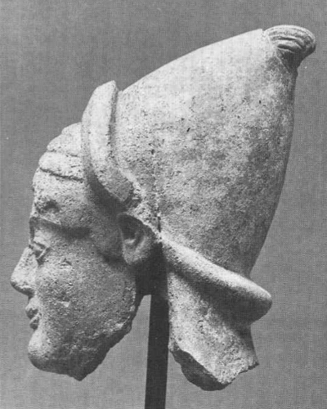

The Tutulus was also a high-crowned, small brimmed hat that the etruscan women wore. The tutulus was a symbol of special status for a Roman woman when she became the mater familias. It was a special hairstyle where the hair was drawn to the top of the head, creating a conical shape.

<https://lowelldesigns.com/the-etruscans/>

<https://www.wordnik.com/words/tutulus>

Tortora, Phyllis G, and Keith Eubank. *Survey of Historic Costume*. 5th ed., Fairchild, 2010.

1. Umbo
2. Vitta - Abby Fluckiger

The vitta was a type of fillet or headband tied around the head, worn by women in ancient Rome to signify their marital and social status (Tortora and Eubank 92). It could be worn by maidens or by married women, though different types of vittae were worn by each, and were also sometimes used for sacred purposes; in any case, they always signified a freeborn woman. They were woolen, could be white or purple, and might be embroidered or laid with pearls (penelope.uchicago.edu).

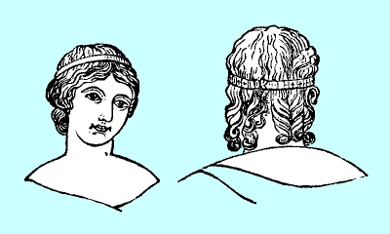

Tortora, Phyllis G, and Keith Eubank. *Survey of Historic Costume*. 5th ed., Fairchild, 2010.

[https://penelope.uchicago.edu/Thayer/E/Roman/Texts/secondary/SMIGRA*/Vitta.html](https://penelope.uchicago.edu/Thayer/E/Roman/Texts/secondary/SMIGRA*/Vitta.html)

<http://www.perseus.tufts.edu/hopper/text?doc=Perseus:text:1999.04.0063:entry=vitta-cn>

1. Where was Etruia? - Esther Wambold 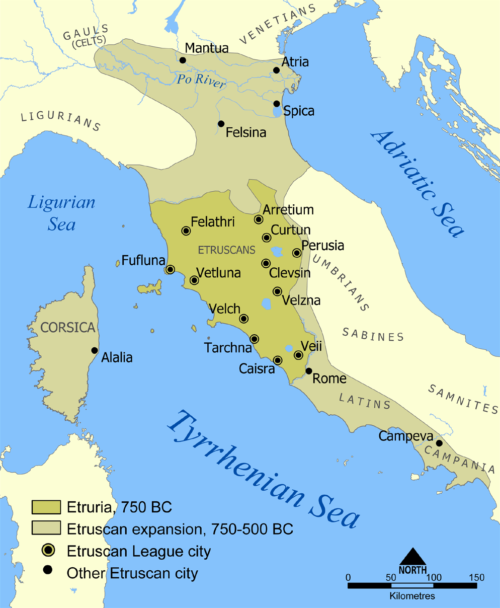

Etruria was an ancient country located in modern-day central Italy. It was located in between the Arno and Tiber rivers and covered Tuscany and part of Umbria. Etruria is often divided into two territories Northern and Southern Etruria. Northern Etruria covered much of modern Tuscany and part of Umbria. Southern Etruria covered the southern part of Tuscany and all of northern and central Lazio. They also had separate names for the northern and southernmost territories. The northernmost territories were called Etruria Padana, which covered part of Emilia-Romagna and the southern parts of Lombardy and Veneto. The southernmost territories were called Etruria Campana and covered part of the Campania region.

Wikipedia Contributors. (2021, December 10). *Etruria*. Wikipedia; Wikimedia Foundation. <https://en.wikipedia.org/wiki/Etruria>

Etruria | ancient country, Italy | Britannica. (2022). In *Encyclopædia Britannica*. <https://www.britannica.com/place/Etruria-ancient-country-Italy>

*Dictionary*. (2022). Www.dictionary.com. <https://www.dictionary.com/browse/etruria>

1. Describe the dress of Etruria
2. Flammeum - Marisa Bone

A Flammeum is a (Flame-colored) Veil worn by a Roman bride. It covered the head and/with the exception of the face. It would descend over the back to the feet. When the bride was brought into the nuptial chamber, the veil was removed by the bridegroom. It was believed to have apotropaic powers and was used primarily to ward away evil spirits as it believed that the bride was incredibly vulnerable during this time in her life. It is thought that as the red veil is to cover her from head to toe it would give the impression that she is on fire, hence giving her her apotropaic power.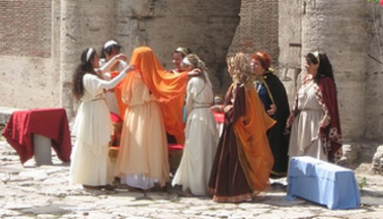

Sources: [Source 1](http://www.perseus.tufts.edu/hopper/text?doc=Perseus:text:1999.04.0063:id=flammeum-cn) [Source 2](https://www.ancient-origins.net/history-ancient-traditions/origins-bridal-veil-0011480) Survey Of Historic Costume

1. Etruscans- Andrea Lazaro Hernandez

The Etruscan civilization was located in the peninsula of what is Italy today. The Etruscan’s economy mostly came from trade, which allowed Etruscans to mix with other Mediterranean cultures, and be influenced by them too. The art and dresses of the Etruscans were greatly influenced by the Greeks. Entruscan art consisted mostly of wall paintings, pottery and sculptures. Finally, the Entruscan civilization was absorbed by the Roman Empire, who incorporated a great part of Entruscan’s culture to their own, including their artistic, political and religious traditions.

Sources:

Survey of Historic Costume, page 75

<https://www.khanacademy.org/humanities/ap-art-history/ancient-mediterranean-ap/ap-ancient-etruria/a/the-etruscans-an-introduction>

<https://www.worldhistory.org/Etruscan_Art/>

STOLA: MADISON FROST

This is a traditional roman garment worn by women. Looks like a toga and is usually made of wool. It was a long dress that reached down to the feet and draped over the shoulder. It was also sleeveless. A palla would be worn on top of this dress.